**Literature Survey :**

Ilkko et al4 proposed UbiPILL A Medicine Dose Controller of Ubiquitous Home Environment (2009), Home automation and wi-fi sensor community that have improving the fine of lifestyles via way of means of imparting protection, facts and comfort. Here had talk a centric domestic server with 3 important roles: use of present Interfaces on registered structures for far flung tracking and Control, serving the encircling machine as a information gateway and Providing content material adaptive consumer interfaces stronger via way of means of Belongings of end-consumer patron gadgets, the ubipill tool had carried out to remind human beings for elder and for tracking functions ubipill and domestic server were layout to reliably display the medication field interest via way of means of internet browser. Kliem et al5 proposed Security and communique structure for networked scientific gadgets in mobilityaware eHealth environments (2012), Telemedicine idea is fee green and vicinity self sustaining tracking machine, the perfect and secured scientific information may be transferred with exceptional gadgets with interest toward protection and privateness difficulty. Emergency conditions want at the flutter community integration and information transmission fluctuating from domain names like sufferers domestic, scientific practices, ambulances and, hospitals, in which every area can also additionally parallel to a exceptional authority so, mobility conscious method permitting out of the field scientific tool integration and authentication, and concurrently gratifying the standard protection and privateness necessities of e-fitness environments. Parida et al3 proposed Application of RFID Technology for In-House Drug Management System (2012), RFID primarily based totally era have used to make drug control machine, on this monitoring of medication may be executed together with emergency or ordinary remedy without or with RFID tag .the HF tag have assigning the consumer and via way of means of using RFID reader at the side of digital digicam and internet primarily based totally machine to music the consumer. This machine may be useful for the antique age, much less knowledgeable human beings. Clifton et al2 A Self-powering Wireless Environment Monitoring System Using Soil Energy, proposed A largescale medical validation of an incorporated tracking machine withinside the emergency department(2013),In the incorporated affected person tracking which consist of digital affected person information which normally have greater quantity demanding situations to collect address artefact information with the assist of algorithm, reading and speaking the consequent information for reporting to clinician, right here on this tested the device studying era embedded inside healthcare facts machine which offer medical blessings for enhancing affected person effects in busy environments. Hamida et al6 proposed toward green and stable in-domestic wearable insomnia tracking and analysis machine (2013), Due to the evolution in era it's far now viable to unique timing tracking right here provides an experimental estimation of communique and protection protocols that may be utilized in in-domestic sleep tracking and fitness care and highlights the maximum right protocol in phrases of protection and overhead. Design Procedures are then derived for the distribution of powerful in-domestic sufferers tracking structures Ray et al7 proposed Home Health Hub Internet of Things (H3IoT)( 2014) , Health is essential a part of lifestyles and it's far pretty important to offer precedence fitness associated difficulty wherein digitization useful via way of means of the usage of quantity of gadgets thru the idea of IOT however because of heterogeneity and interoperability the idea of digitization for fitness care is neglected, right here on this the high-satisfactory consciousness given to structure framework for human fitness hub that have envision of utilization of actual lifestyles implementation.the information from transmitter may be sending to cloud for centralized tracking takes region; the professional in far flung region can view all affected person information and in case of emergency can take suitable action. Ajmal Sawand et al1 proposed Multidisciplinary procedures to reaching green and sincere eHealth tracking structures(2014),The technological merging among IOT, wi-fi frame location community and cloud computing have essential contribution in e fitness care which enhance the fine of scientific care, essentially affected person centric tracking play a function in e fitness care offerings which contain scientific information collection, aggregation, information transmission and information evaluation right here whole tracking lifecycle and critical offerings thing have discus in addition to layout demanding situations in designing the fine and affected person centric tracking scheme at the side of capability solution. Huang et al8 proposed the sensible tablet field—Design and implementation (2014), the implementation of tablet field has proposed via way of means of maintaining the issues of antique age human beings in thoughts to offer complete medicinal drug safety. The tablet field will remind the affected person approximately timing via way of means of doing this drug abusing may be controller.

which make quality of life, in case of density of messages there is fear of information degradation but by using proper algorithm we can resolve the problem and can make the low cost imaging, sensing and human computer interaction technology. Lin et al9 proposed A Selfpowering Wireless Environment Monitoring System Using Soil Energy (2015), The monitoring system can uses the self-powering wireless environment with the help of renewable energy which can be beneficial in remote places where the power problem in wide manner, in this the system have demonstrated which will uses soil energy with carbon, zin

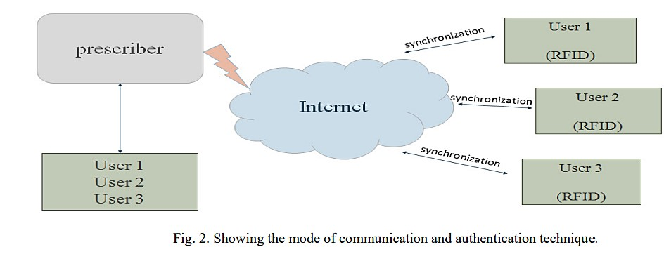

3. Useful Technique for Medicine Reminder and Monitoring System . After observing all the literature, the following technologies are identified which can prove

beneficial for designing of Medicine Reminder and Monitoring System for Secure Health Using IOT.

> UI: To make changes if any in system.

> Intelligent control: Control system comprising sensors for monitoring and reporting the state of the environment and its associated control software, which regularly check the medicine taken by patient or not . x IoT:( Internet of Things) has evolved from the convergence of wireless technologies, microelectromechanical systems (MEMS) and the Internet. The concept may also be referred to as the Internet of Everything. to exchange data of things or physical object, this is embedded with electronics, related software, sensors and network connectivity. Which allow to sensed and collect data remotely, it generate opportunity to direct integration between physical world and computer based system have economic, accuracy and efficiency benefits. x The use of open standard like ISO/IEEE 11073-20601 group of standards addressing the interoperability of personal health devices12

> MQTT messaging protocol will best suited due to less memory, processor and bandwidth13 x

The use of open source IOT cloud will be effective.

> RFID and RFID reader: RFID is utilized to give unique identification to user so that while remote monitoring the prescriber can distinguish the patient on same page14

> Web page: web page will be used for remote monitoring of medicine scheduled fallowed by patient and to upload the changes if any found after comparing the variation in medicine consuming activity in scheduling, quantity, timing of drug.

> Alarm System: The alarm system is used to give the indication of medicine through voice message.

>Appointment from home: The provision will be on the box which will take patient appointment of the doctor here, RFID will be the Identity of patient.

> Benefit of using RFID tag: Used for Encryption/Decryption Technology15 4. Working Flow Chart

Working flow chat

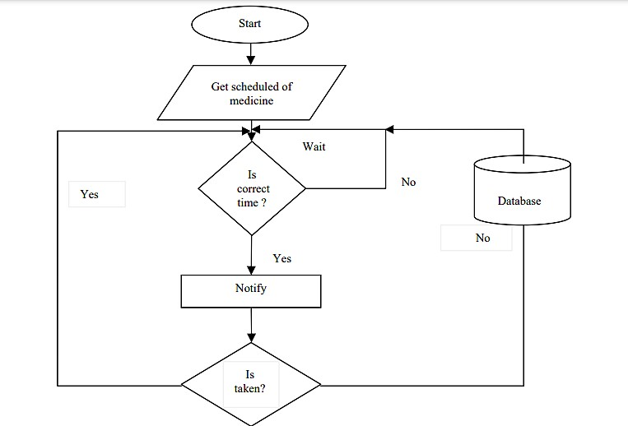

The conceptual working of medicine reminder and monitoring system in flow chart describes the scheduling and the procedure of taking medicine, if schedule is followed by patient or not the data will be stored in the cloud. The stored data will be used to analyze record of patient and further prescription will be give according to it.

1. Conclusion

For home health care various technology have evolved as review considered, in this paper medicine, its scheduling have well focused which is beneficial to improve efficiency of prescribed drug and reduce economic factor. To improve the existing home health care technique number of monitoring technology has observed which leads to home health monitoring system. The monitoring system can be implemented with sensing element and wireless module which should need to secure so that message containing the health related information should not be corrupt. IOT (Internet of Things) play a vital role in communicating the two devices, the use of messaging standard and communication protocol we can securely transfer the important messages regarding to health. open source IOT cloud will be effective for storing sensors data,the benefit of digitally storing is the retrieving of data is easy and faster manner in case of emergency for secure health. For the user personal identity and